Labaratoriya -8
PHP orqali fayl yuklash va saqlash moduli
PHP orqali fayl yuklash (upload) va serverda saqlash — bu web dasturlashdagi juda muhim funksiyalardan biri. Keling, tushunarli qilib bosqichma-bosqich ko‘rib chiqamiz.

HTML forma yaratish
Fayl yuklash uchun forma enctype="multipart/form-data" bo‘lishi shart:
<form action="upload.php" method="post" enctype="multipart/form-data">
<input type="file" name="file">
<button type="submit">Yuklash</button>
</form>
2. PHP orqali faylni qabul qilish
PHP da yuklangan fayllar $_FILES massivida saqlanadi:
<?php
$file = $_FILES['file'];
echo $file['name']; // Fayl nomi
echo $file['tmp_name']; // Vaqtinchalik joylashuvi
echo $file['size']; // Fayl hajmi
echo $file['type']; // MIME turi
?>
3. Faylni serverga saqlash
Faylni doimiy papkaga ko‘chirish uchun move_uploaded_file() ishlatiladi:
<?php
$targetDir = "uploads/";
$fileName = basename($_FILES["file"]["name"]);
$targetFile = $targetDir . $fileName;
if (move_uploaded_file($_FILES["file"]["tmp_name"], $targetFile)) {
echo "Fayl muvaffaqiyatli yuklandi!";
} else {
echo "Xatolik yuz berdi.";
}
?>
4. Xavfsizlik tekshiruvlari (MUHIM ⚠️)

Fayl turini tekshirish:
$allowedTypes = ['jpg', 'png', 'pdf'];
$fileType = strtolower(pathinfo($targetFile, PATHINFO_EXTENSION));
if (!in_array($fileType, $allowedTypes)) {
echo "Ruxsat etilmagan fayl turi!";
exit;
}

Fayl hajmini cheklash:
if ($_FILES["file"]["size"] > 2 * 1024 * 1024) {
echo "Fayl juda katta!";
exit;
}

Unikal nom berish:
$fileName = uniqid() . "_" . basename($_FILES["file"]["name"]);

5. PHP sozlamalari (php.ini)
Ba’zi holatlarda quyidagi sozlamalarni o‘zgartirish kerak bo‘ladi:
- upload_max_filesize — maksimal fayl hajmi
- post_max_size — POST so‘rov hajmi
- max_file_uploads — bir vaqtning o‘zida nechta fayl

6. Papka ruxsatlari
uploads/ papkasi yozish uchun ruxsatga ega bo‘lishi kerak:
chmod 755 uploads/

Index.html
<!DOCTYPE html>
<html>
<head>
<title>Fayl yuklash</title>
</head>
<body>

<form action="upload.php" method="post" enctype="multipart/form-data">
Fayl tanlang:
<input type="file" name="file">
<br><br>
<input type="submit" name="submit" value="Yuklash">
</form>

</body>
</html>

Upload.php
<?php

if(isset($_POST['submit'])) {

$file_name = $_FILES['file']['name'];
$file_tmp = $_FILES['file']['tmp_name'];
$file_size = $_FILES['file']['size'];
$file_error = $_FILES['file']['error'];

// Fayl joylashadigan papka
$upload_dir = "uploads/";

// Papka mavjud bo�lmasa yaratamiz
if(!is_dir($upload_dir)){
mkdir($upload_dir);
}

// Faylni saqlash
$target_file = $upload_dir . basename($file_name);

if($file_error === 0){
if(move_uploaded_file($file_tmp, $target_file)){
echo "Fayl muvaffaqiyatli yuklandi!";
} else {
echo "Xatolik yuz berdi!";
}
} else {
echo "Fayl yuklashda xatolik!";
}
}

?>

Natija:
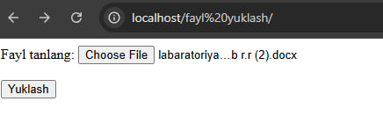

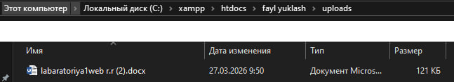

Xulosa
PHP da fayl yuklash moduli quyidagilarni o‘z ichiga oladi:
- HTML forma (multipart/form-data)
- $_FILES orqali ma’lumot olish
- move_uploaded_file() bilan saqlash
- Xavfsizlik tekshiruvlari (format, hajm, nom)

